The "Get-Acquainted Social"

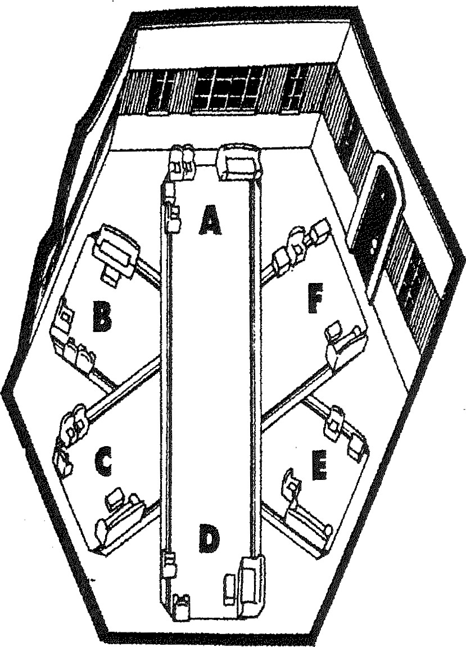
“A Skills" Common theme: Interact with the physical world
- Interact with the physical world using physical appendages
- Interact with physical world through senses
- Build, create, or construct something that didn't exist before

" B Skills" Common theme: Methodical, sequential, detailed thinking
- Attracted to facts, information, data; especially where precision/accuracy are needed
Plan and execute a plan; employ methodical, sequential, and orderly approach
- Improve or fine turn processes and procedures that currently exist

"C Skills" Common Theme: Initiate action to get a lot done
- Take action; initiate quick, short-term activities or tasks
- Interact with people to direct, influence, and organize people to get a lot done
Display showmanship, project confidence or commitment

" D Skills" Common theme: Interact for the exchange of emotional energy
- Talk about feelings; express compassion, love, acceptance
- Nurture, mentor; help others understand their emotions
Form emotional bonds with a wide range of people

"E Skills" Common theme: Random thinking
- Attracted to the abstract; philosophy, theory, concept, idea
- Generate ideas about possibilities; envision new, original, different ideas
- Use intuitive reasoning; get sensation or impression
“F Skills" Common theme: Break whole into its parts
- Research, investigate, interview, probe
Analyze, dissect, evaluate, compare, contrast
Study to learn, understand, discover, self-discovery.

